DLP HW3

多工所碩一 楊奕儒

ID：312553038

1. **Introduction**

In this lab, I implemented the ResNet18, ResNet50, ResNet152 architecture and my own DataLoader to read data from dataset.csv.

The dataset is about Leukemia Classification with 10,661 images and each image with 2 labeled classes.

**2. Implementation Details (30%)**

**A. The details of your model (ResNet)**

The number of ResNet means that how many layers in the model.

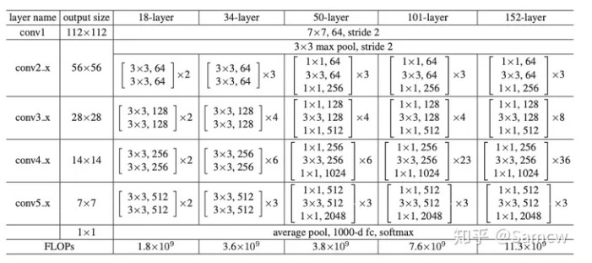In ResNet18, I implemented the basic block to constitute the model. A basic block consists of two 2D convolutional layers, each followed by batch normalization and a ReLU activation function.The shortcut connection which used to solve the degradation problem is necessary when the input and output channels differ or when the stride of the first convolutional layer is greater than 1.

In ResNet50 and Resnet152，I implemented the Bottleneck block.

Each model containing a specific number of Bottleneck blocks. The Bottleneck block contains three convolutional layers with batch normalization and ReLU activation functions.

The make_layer function generates a sequential block of Basic block(In Resnet18) or Bottleneck(In Resnet50 and Resnet152) instances based on the number of num_blocks specified for each layer/stage.

**B. The details of your Dataloader**

In getData function, there are five mode to determine which csv should be read and return. In class LeukemiaLoader, I transform the picture by RandomRotation, RandomHorizontalFlip, CenterCrop, ToTensor and Normalize, and return the image, label, and path.

**C.** **Describing your evaluation through the confusion matrix**

There are fournumbers in the confusion matrix.It’s True Positives (TP), True Negatives (TN), False Positives (FP), False Negatives (FN) respectively. I can calculate the accuracy by (TP + TN) / (TP + TN + FP + FN).

**3. Data Preprocessing (20%)**

**A. How you preprocessed your data?**

I transform the picture by RandomRotation, RandomHorizontalFlip, CenterCrop, ToTensor and Normalize

**B. What makes your method special?**

After observing many photos, I noticed that the main shapes are mostly circular and distributed in the center of the images. Therefore, I chose to use transformations such as RandomRotation, RandomHorizontalFlip, and CenterCrop on the input data. I believe that incorporating these changes will not significantly alter the features of the shapes but, instead, will help the model learn more intricate details.

**4. Experimental results (10%)**

**A. The highest testing accuracy**

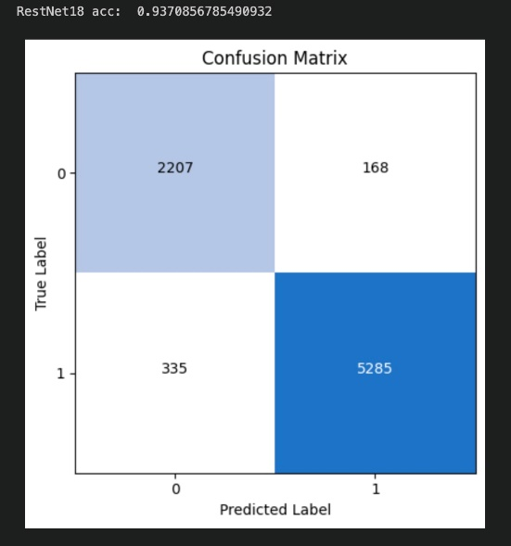

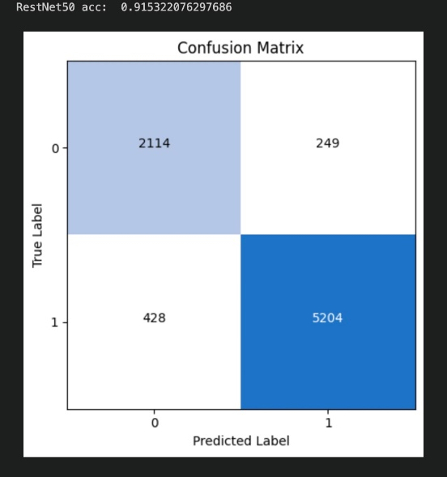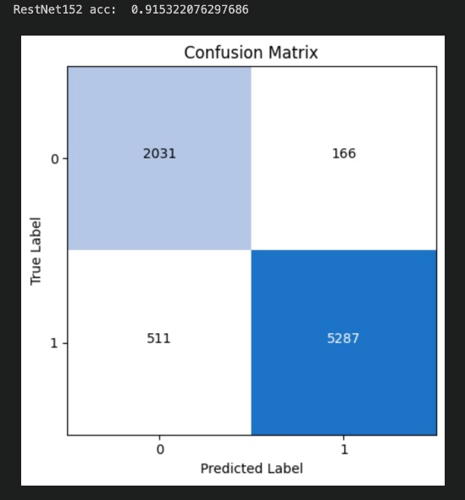

**B. Comparison figures**

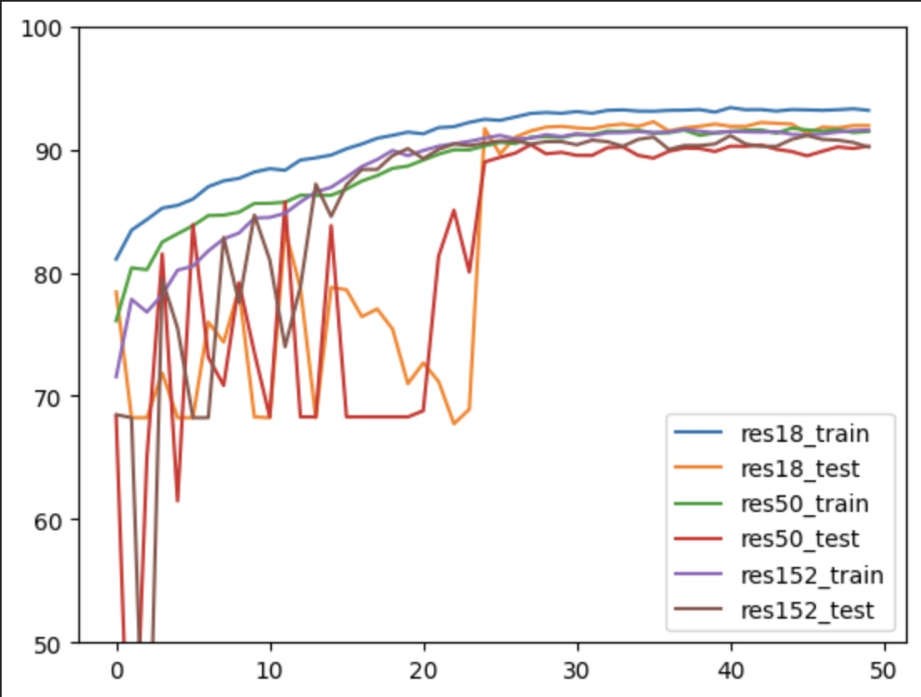

**5. Discussion (30%)**

This is my first time implementing a deep neural network with so many multiple layers, and it's also my first time learning about issues like degradation that can occur in deep networks. During the initial stages of training and testing, I noticed that the accuracy fluctuates significantly. I suspect this might be related to the difficulty of learning image features and the choice of learning rate. Due to time constraints, I couldn't conduct more tests this time. If I encounter similar problems in the future, I may consider modifying the way the learning rate changes during training to help the model converge faster.